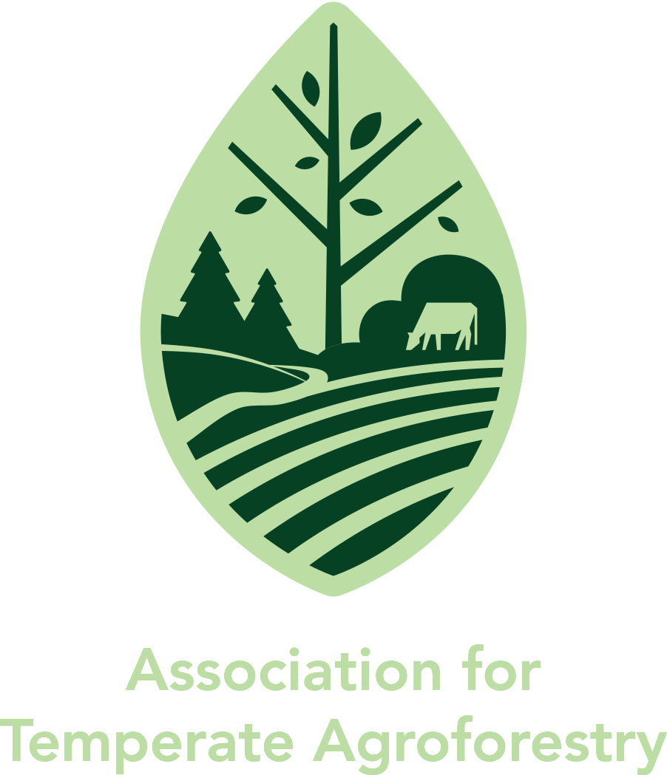

**2025**

**Association for Temperate Agroforestry (AFTA)**

**Awards Application**

**Applicant Information:**

Name:

Title:

Affiliation:

Address:

Phone:

Email:

Website:

Years of Service:

**Select Award:**

___ Outreach and Education

___ Research

___ Practitioner or Producer

___ Early Career

**Award Narrative:** (150 words) (Reasons this person deserves to be recognized)

**Attachments** (2 attachments):

Materials that support and illustrate impacts, outcomes, and achievements in agroforestry.

**Submission Instructions:**

* Download or make a copy of this form, fill it out and save as a PDF.
* Send a single email using the subject line ‘2025 AFTA Award Nomination’ with a complete nomination form and supporting materials to [caruthersad@missouri.edu](mailto:caruthersad@missouri.edu) no later than May 4, 2025.

Questions may be directed to Hannah Hemmelgarn at [hemmelgarnh@missouri.edu](mailto:hemmelgarnh@missouri.edu).