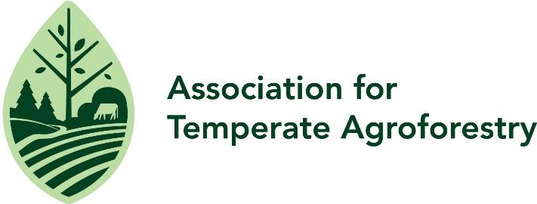

2025 North American Agroforestry Conference Scholarship Form

We are committed to making our conference as accessible as possible, regardless of participants’ financial circumstances. To support this goal, we are offering need-based scholarships to help offset the cost of attending. These scholarships are intended to assist individuals who indicate financial need and will benefit from participating in the event.

Scholarships may be used toward conference expenses such as registration fees, travel, and accommodations. The availability of funds is limited, and awards will be granted based on the review of information provided in this application.

Please complete the form below. All information will be kept confidential and used solely to evaluate scholarship eligibility and award amounts. If you have questions or need assistance completing the application, please contact Andria Caruthers at caruthersad@umsystem.edu. Priority review for early applications. Deadline for application submission is May 30th, 2025.
____________________________________________________________________________

Applicant first name: Click or tap here to enter text.
Applicant last name: Click or tap here to enter text.

Email address:Click or tap here to enter text.

Registration type: ☐General attendee ☐Farmer ☐Student

Have you or do you plan to submit an abstract for the conference? ☐Yes ☐No

What is the latest date by which you need to know if you received the award? Month/Day/Year

What is your total estimated cost ($USD) to attend this conference? (e.g., travel, accommodation, registration, meals). For reference, MU residence hall rates are $46-57 per night for single rooms and $29-32 per night per person for double rooms (rate range based on whether or not linen service is needed). $Click or tap here to enter text.

How much funding are you requesting as a scholarship to offset your costs? $Click or tap here to enter text.

Please provide a dollar amount ($USD) breakdown of how the scholarship funds would be used:

Conference registration: $Click or tap here to enter text.
Lodging: $Click or tap here to enter text.
Travel: $Click or tap here to enter text.
Meals: $Click or tap here to enter text.

Have you or do you plan to apply for or request support from other sources?
Yes☐ No☐

Would you be able to attend the North American Agroforestry Conference without this scholarship funding?
Yes☐ No☐

Would you be interested in the virtual attendance option for the conference? ☐Yes ☐No

Please briefly share why you would like to attend the 2025 North American Agroforestry Conference.
Click or tap here to enter text.

Email the completed scholarship form to Andria Caruthers at caruthersad@umsystem.edu

